KENILWORTH KAROLING 2021: LIGHT THE WINTER SOLSTICE

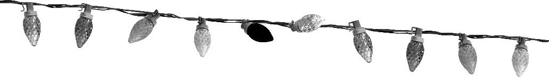
WINTER WONDERLAND/SILVER BELLS/JINGLE BELL ROCK [Necklaces: As you wish]
STEPHEN PYLE (Piano recording)

MELE KALIKIMAKA [Necklaces: FAST FLASHING]

RUDOLPH THE RED-NOSED REINDEER [Necklaces: FLASHING your choice - SING ALONG]

SNOWBIRD [Necklaces: SLOW FLASH]

BASHANA HABA’AH [Necklaces OFF] SHHhhh. QUIET PLEASE – JUST LISTEN
Partial translation: We will spread out our hands towards the radiant light. A white heron like a light will spread her wings and within them the sun will rise. (AGMC recording/Stephen Pyle, Accompanist)

WE NEED A LITTLE CHRISTMAS [Necklaces: FLASHING MIX – SING ALONG]

THE CHRISTMAS STORY IN CAROLS [Necklaces: STEADY]
Live – AMITAVA SEN – Violin

SANTA CLAUS IS COMING TO TOWN [Necklaces: FAST FLASH]
Live – MICHAEL FRAZIER – Piano & Vocals

I LOVE THOSE J.I.N.G.L.E. BELLS [Necklaces: SLOW FLASH]

I’LL BE HOME FOR CHRISTMAS [Necklaces: STEADY]
DIANE KYLE (Vocal recording)
WHITE CHRISTMAS [Necklaces: YOUR CHOICE]
SING ALONG!

THE CHRISTMAS SONG [Necklaces: SLOW FLASHING]
Live - MICHAEL FRAZIER – Piano & Vocals

SEASONAL POPS
Live – AMITAVA SEN – Violin [Necklaces: FLASH MIX]

SLEIGH RIDE [Necklaces: SLOW FLASH]
STEPHEN PYLE (Piano recording)

YOU JUDGE BEST BOAT – HAPPY HOLIDAY [Necklaces: YOUR CHOICE]
Choose your favorite, mark your ballot – place in BOAT STOCKING at Pavilion

CHRISTMASTIME ALL OVER THE WORLD [Necklaces: FLASHING MIX]

SILENT NIGHT [Necklaces: OFF]
Live - MICHAEL FRAZIER – Piano & Vocals

ROCKIN’ AROUND THE CHRISTMAS TREE [Necklaces: FLASHING MIX]
SING ALONG!

SOMEDAY AT CHRISTMAS [Necklaces: AS YOU WISH!]
Head to Pavilion to enjoy some snacks, a cocktail, your neighbors and the season!

THANK YOU FOR PARTICIPATING!
Merry Christmas, Happy Winter Solstice and Happy Holidays!

